COMSATS University Islamabad
Department of Computer Science
CSC291 Software Engineering
Semester: Spring 2026
BS(AI) - Section 6A

Assignment No. 3 - Data and User Interface Design
Group No. 15

Project Title
ShareWay - AI Powered Peer-to-Peer Ride Sharing Platform

Submitted By:
Syed Muhammad Shahzaib Haider Rizvi
FA23-BAI-050
Module: Authentication, Profile & Vehicle Management Module

Submission Date: May 04, 2026

1. Project Overview
ShareWay is a cross-platform mobile application built with Flutter that facilitates peer-to-peer ride-sharing among urban commuters in Pakistan. The system uses Firebase for real-time backend services (Authentication, Cloud Firestore, Cloud Messaging) and OpenStreetMap for all map operations (Nominatim for geocoding, OSRM for routing). A weighted AI-driven matching algorithm scores potential rides on route similarity (40 percent), time overlap (30 percent), driver rating (20 percent) and pickup proximity (10 percent), so that passengers are connected to the most suitable drivers.
The application supports dual user roles (driver and passenger), real-time messaging, live GPS tracking, ratings & reviews, ride history, and four Pakistani payment methods (Cash, Easypaisa, JazzCash, Bank Transfer). The interface follows a dark glassmorphism design with a mint-green accent palette.

2. AI-Driven Techniques Applied
AI-driven techniques were applied at two levels: inside the product itself, and during the design process.

2.1 AI inside the product
These were designed by the team and are visible in the data design of every module:
- Weighted Ride-Matching Algorithm - a multi-factor scoring model that ranks candidate rides for each passenger query.
- Route Similarity via geo-spatial comparison - haversine distance and polyline overlap produce a 0-1 similarity score that drives the Rides collection schema.
- ETA Prediction - OSRM-derived duration is corrected using historical completion deltas stored on each ride.
- Sentiment-Aware Rating Pipeline - short reviews are classified positive / neutral / negative; results feed into the user trust score.
- Smart Notification Bundling - events from the same ride within a 60-second window are grouped into a single push notification.

2.2 AI used during the design process
The data design and UI specifications in this document were authored by the team. Figma's AI-assisted features (auto-layout, content fill, component-name hints) were used as a lightweight aid to keep spacing, typography and naming consistent across screens. All validation rules, navigation flows and entity-relationship choices are the team's own work.

3. Authentication, Profile & Vehicle Management Module
This module owns user identity, profile management and the driver's vehicle records. It is the entry-point of the application and feeds user identifiers into every other module of ShareWay.

3.1 Data Design
Three Firestore collections back this module: users (a top-level collection keyed by Firebase Auth UID), users/{uid}/vehicles (a subcollection holding each driver's vehicles), and a lightweight passwordResetAudit log. Firebase Authentication is the source of truth for credentials; the users document mirrors profile data so that other modules can read it without a round-trip to Auth.
Entity: users
Attribute | Type & constraints | Description
uid | string (PK), = Firebase Auth UID | Document ID, immutable
displayName | string, 2-50 chars | Public name shown to other users
email | string, RFC-5322, unique | Login identifier
phone | string, +92XXXXXXXXXX, OTP verified | Used for ride contact
photoUrl | string, nullable | Avatar URL in Firebase Storage
role | enum: passenger | driver | both | Active role(s)
rating | double, 0.0-5.0, default 0.0 | Aggregate star rating
totalRides | int, >= 0, default 0 | Completed rides count
paymentMethods | array<string> from {cash, easypaisa, jazzcash, bank} | User preference
fcmToken | string, nullable | Push notification token
createdAt | timestamp (server) | Account creation
updatedAt | timestamp (server) | Last profile change
Entity: users/{uid}/vehicles (subcollection)
Attribute | Type & constraints | Description
vehicleId | string (PK), auto-id | Document ID
make | string, required | e.g. Toyota
model | string, required | e.g. Corolla GLi
color | string, required | e.g. White
licensePlate | string, Pakistan plate regex, unique per user | e.g. LEA-1234
seats | int, 1-4 | Passenger seats available
vehicleType | enum: sedan | hatchback | suv | motorcycle | Used in search filter
createdAt | timestamp (server) | Vehicle added on
Entity: passwordResetAudit
Attribute | Type & constraints | Description
resetId | string (PK), auto-id | Audit record id
email | string, required | Account requesting reset
requestedAt | timestamp (server) | When link was sent
completedAt | timestamp, nullable | When password was changed
ipAddress | string, anonymised | Source IP for fraud check
Integrity & validation rules:
- uid is created by Firebase Auth and is immutable - it is the foreign key referenced by Rides, Ratings, Messages and Notifications.
- email and phone are uniquely indexed; phone numbers must pass +92 OTP verification before the user document is committed.
- If role = driver or both, at least one vehicle document must exist before that user can publish a ride.
- Deleting a user document soft-deletes (sets status = deactivated) so historical rides and ratings remain valid.

3.2 User Interface Design
All screens in this module follow the ShareWay design system: dark navy background (#1B293F), mint-green accent (#2EC4A0), rounded fields (12 px corner radius), and inline live validation. The module covers six screens.
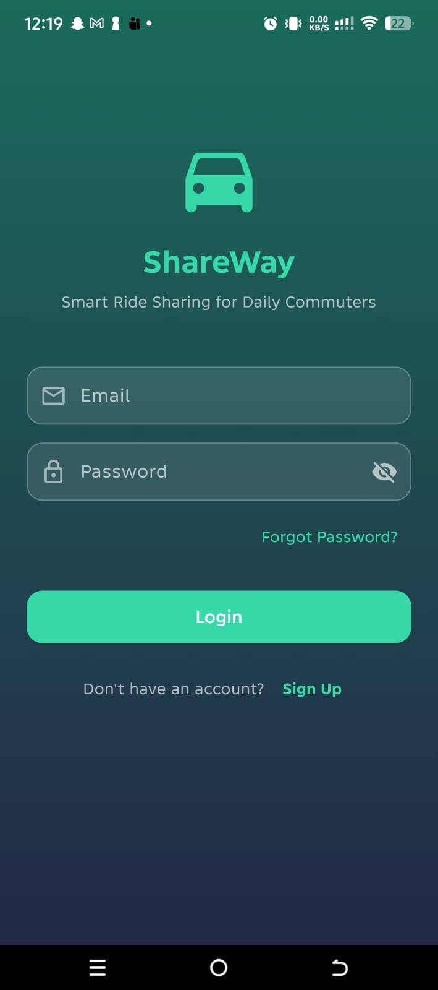 | 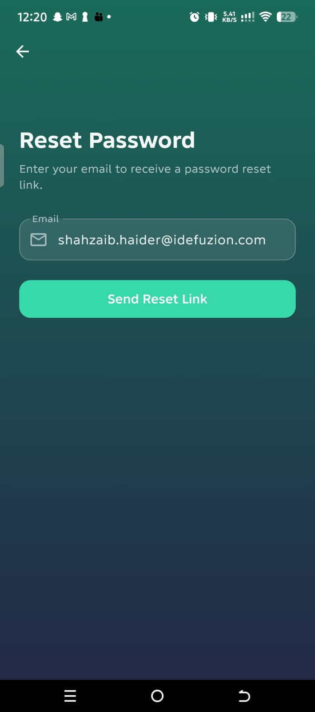
Login screen | Reset Password screen

Screen 1 - Login (Input)
Authenticates an existing user against Firebase Authentication.
Inputs and controls:
- Email: text input with envelope icon, RFC-5322 validation, required.
- Password: password input with lock icon and show/hide eye, minimum 8 characters.
- Forgot Password?: text link that navigates to the Reset Password screen.
- Login: primary mint button, enabled when both fields are valid; calls FirebaseAuth.signInWithEmailAndPassword.
- Sign Up: inline text link that navigates to the Sign Up screen.
Outputs and states:
- Success - navigate to Find Ride home with a fade transition.
- Invalid credentials - red inline message: 'Invalid email or password'.
- Offline - snackbar: 'No internet connection'.

Screen 2 - Sign Up (Input)
Creates a new account with phone OTP verification.
Inputs and controls:
- Full Name: text input, 2-50 characters.
- Email: text input, RFC-5322 with uniqueness check on blur.
- Phone Number: phone input pre-filled with +92, 10 digits required.
- Password: password input, minimum 8 chars and 1 letter + 1 number.
- Confirm Password: must equal Password.
- Account Type: segmented control: Passenger | Driver | Both (default Passenger).
- Send OTP: button - enabled once phone is valid; triggers SMS via Firebase.
- OTP Code: 6-digit numeric input with a 60-second expiry timer.
- Create Account: primary button - writes the users document and FCM token after OTP success.
Outputs and states:
- Success - user lands on Find Ride home with a welcome banner.
- Duplicate email - red inline error.
- OTP failure - 'Code incorrect, try again' with cooldown timer.

Screen 3 - Reset Password (Input)
Triggers a Firebase Auth password reset email.
Inputs and controls:
- Back arrow: icon button (top left) - returns to Login.
- Email: text input, pre-filled if it was entered on Login.
- Send Reset Link: primary button - calls FirebaseAuth.sendPasswordResetEmail.
Outputs and states:
- Success - 'Reset link sent to your email' snackbar.
- Account not found - 'No account found with that email'.
- Throttled - 'Please wait before requesting another link'.
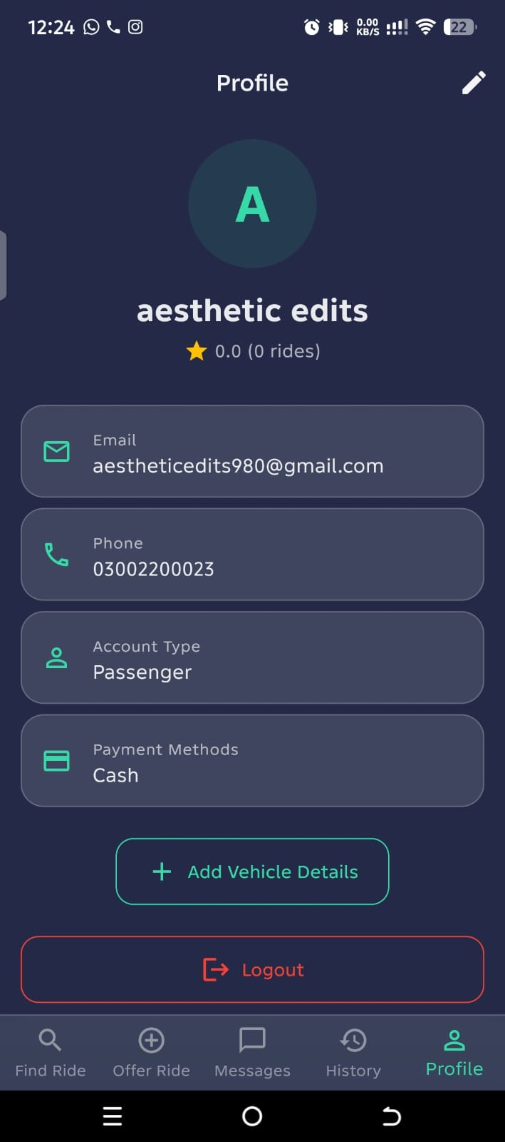
Profile screen

Screen 4 - Profile (Output)
Displays the current user's identity, rating, payment preferences and registered vehicles.
Inputs and controls:
- Edit (pencil icon, top right): navigates to Edit Profile.
- Add Vehicle Details: outlined mint button - opens the Add Vehicle screen.
- Logout: outlined danger button - signs out and clears local state.
Outputs and states:
- Avatar - users.photoUrl (initial-letter fallback).
- Display Name (large) and 'star + rating + (N rides)' beneath.
- Email and Phone cards (read-only).
- Account Type card - Passenger / Driver / Both.
- Payment Methods card - comma-separated active methods.
- Vehicle list (drivers only) - one card per registered vehicle.

Screen 5 - Edit Profile (Input)
Updates editable profile fields and refreshes the users document.
Inputs and controls:
- Avatar: tap to upload from gallery or camera; <= 2 MB.
- Display Name: text input, 2-50 characters.
- Phone Number: phone input - re-OTP if changed.
- Payment Methods: multi-select chips, at least one selected.
- Active Role: segmented control.
- Save: primary button - writes the diff to Firestore.
- Cancel: text button - discards changes.
Outputs and states:
- Success - snackbar 'Profile updated' and navigate back.
- Phone re-OTP - moves to OTP verification flow first.

Screen 6 - Add / Edit Vehicle Details (Input)
Registers or edits a vehicle so the driver can publish rides.
Inputs and controls:
- Make: text input with auto-suggest from a dictionary list.
- Model: text input, 2-30 characters.
- Color: color-picker chips, required.
- License Plate: text input (uppercase) matching the Pakistan plate regex.
- Available Seats: stepper, 1-4.
- Vehicle Type: segmented control: sedan | hatchback | suv | motorcycle.
- Save Vehicle: primary button - writes to the vehicles subcollection.
- Delete Vehicle: outlined danger (in edit mode) - confirm dialog then removes.
Outputs and states:
- Success - snackbar 'Vehicle saved' and pop back to Profile.
- Plate format error - inline red message under the field.

3.3 Report - User Registration & Activity
An admin-facing weekly report driven directly off the users and passwordResetAudit collections. The mock-up below shows the default monthly view.
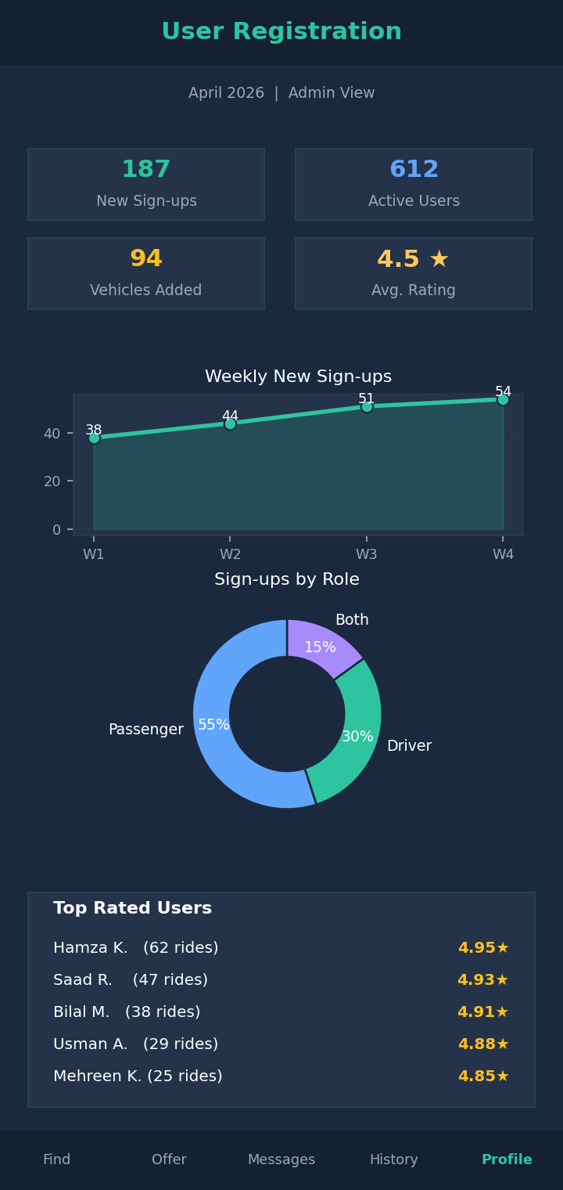
User Registration & Activity Report (admin view)
Metrics included:
- New sign-ups in the period (count of users.createdAt).
- Active users (at least one ride or message in the period).
- Drivers / Passengers / Both - role distribution pie.
- Vehicles registered in the period.
- Average rating across users.
- Top rated users (name, rating, total rides).
- Password reset requests per day from passwordResetAudit.

3.4 Personal Contribution - Shahzaib (FA23-BAI-050)
- Designed all three Firestore entities for this module (users, vehicles, passwordResetAudit) including the data dictionary, validation rules and integrity constraints.
- Authored the user-interface specifications for six screens: Login, Sign Up, Reset Password, Profile, Edit Profile and Add / Edit Vehicle.
- Defined the User Registration & Activity report - including the underlying Firestore queries and the mock-up shown above.
- Coordinated naming conventions for shared identifiers (uid, fcmToken) used by the Ride Management and Communication modules.

4. Group Work Distribution Summary
The assignment was split module-wise so that each member owns the data design, UI design and reports for their module end-to-end. Cross-module identifiers (uid, rideId) were agreed in joint sessions before each member began their detailed work.
Shahzaib (FA23-BAI-050) - Authentication, Profile & Vehicle Management.
- Entities: users, users/{uid}/vehicles, passwordResetAudit.
- UI screens: Login, Sign Up, Reset Password, Profile, Edit Profile, Add / Edit Vehicle.
- Report: User Registration & Activity (admin).
Arhum (FA23-BAI-006) - Ride Management.
- Entities: rides, rides/{rideId}/requests, liveTracking, plus the AI matching algorithm specification.
- UI screens: Offer Ride (one-time and recurring), Find Ride, Map Picker, Search Results, Ride Details, Send Request, Driver Inbox, Active Ride / Live Tracking.
- Report: Active Rides Snapshot (admin).
Awais (FA23-BAI-028) - Communication, History & Reports.
- Entities: chats, messages, ratings, notifications, rideHistory, plus four AI components (sentiment, moderation, bundling, summary).
- UI screens: Messages List, Chat, Ride History, Rate & Review, Notifications, Push Notification, Notification Settings.
- Reports: Driver Earnings, Passenger Spend, Ratings Summary, Platform Statistics.

